Experiment Number : 03 Date: 25-01-26

Control Statements in Java
Aim:
To understand and implement decision-making and looping control statements in Java.
PRE LAB EXERCISE
QUESTIONS
- List different control statements in Java.
Java control statements are divided into three categories:
A. Selection (Decision-Making) Statements
- if
- if-else
- else-if
- switch
B. Iteration (Looping) Statements
- for
- while
- do-while
- enhanced for loop (for-each)
C. Jump Statements
- break
- continue
- return

- Difference between for, while, and do-while loops.
Loop | When used | Entry/Exit | Condition Check | Syntax Difference
for loop | When number of iterations is known | Entry-controlled | Condition checked before executing loop | All parts (init, condition, update) in one line
while loop | When number of iterations is unknown | Entry-controlled | Condition checked before loop executes | Only condition appears near loop
do-while loop | When the loop must run at least once | Exit-controlled | Condition checked after executing loop | Ends with while(condition);

- What is the use of break and continue?
break
- Immediately stops the loop
- Control goes outside the loop
- Used in loops and switch statements
Example use:
- To stop loop when condition is met
- To exit a switch case
continue
- Skips the current iteration
- Moves to next iteration of the loop
- Loop does not stop
Example use:
- Skip negative numbers
- Skip unwanted values

IN LAB EXERCISE
Objective:
To implement if-else and looping statements.
INPUT STATEMENT:
SCANNER CLASS
- The Scanner class in Java is used to read input from the user through the keyboard.
It is available in the package java.util.
- The Scanner object reads different types of input such as integer, float, double, and string and stores them in variables.
- To use the Scanner class, it must be imported before using it in the program.
SYNTAX:
- Scanner sc = new Scanner(System.in);
Commonly Used Scanner Methods:
- nextInt() – reads an integer value
- nextFloat() – reads a float value
- nextDouble() – reads a double value
- next() – reads a single word
- nextLine() – reads a complete line of text

PROGRAMS:
Program 1: Check Whether a Number is Positive
package tutorial;
public class PositiveorNegative {
public static void main(String[] args) {
int n = -5;
if (n > 0) {
System.out.println("Positive Number");
}
else {
System.out.println("Negative Number");
}
}
}
Output:
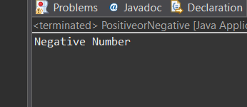
Program 2: Check Whether a Number is Even or Odd
class Even{
public static void main(String[] args) {
int n = 68;
if (n % 2 == 0)
System.out.println("Even Number");
else
System.out.println("Odd Number");
}
}
Output:
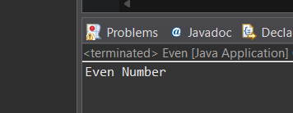
Program 3: Find Largest of Two Numbers
class Largest{
public static void main(String[] args) {
int a = 100, b = 20;
if (a > b)
System.out.println("A is largest");
else
System.out.println("B is largest");
}
}
Output:
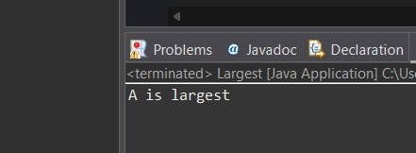
Program 4: Grade Calculation
class Grade {
public static void main(String[] args) {
int marks = 99;
if (marks >= 90)
System.out.println("Grade A");
else if (marks >= 75)
System.out.println("Grade B");
else if (marks >= 50)
System.out.println("Grade C");
else
System.out.println("Fail");
}
}
Output:
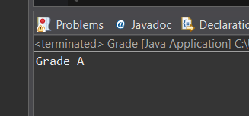
Program 5: Day of the Week
class Day {
public static void main(String[] args) {
int day = 7;
switch (day) {
case 1: System.out.println("Monday"); break;
case 2: System.out.println("Tuesday"); break;
case 3: System.out.println("Wednesday"); break;
case 4: System.out.println("Thursday"); break;
case 5: System.out.println("Friday"); break;
default: System.out.println("Invalid Day");
}
}
}
Output:
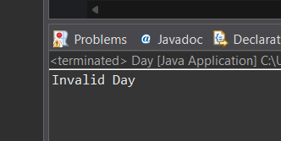
Program 6: Print Numbers from 1 to 5
class For {
public static void main(String[] args) {
for (int i = 1; i <= 5; i++) {
System.out.println(i);
}
}
}
Output:
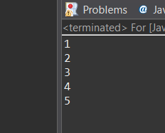
Program 7: Print Numbers from 1 to 5
class While {
public static void main(String[] args) {
int i = 1;
while (i <= 5) {
System.out.println(i);
i++;
}
}
}
Output:
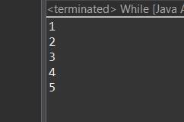
Program 8: Print Numbers from 1 to 5
class Dowhile {
public static void main(String[] args) {
int i = 1;
do {
System.out.println(i);
i++;
} while (i <= 5);
}
}
Output:
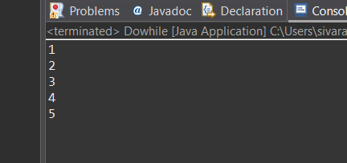
Program 9: Sum of First 5 Natural Numbers
class SumofN {
public static void main(String[] args) {
int sum = 0;
for (int i = 1; i <= 5; i++) {
sum = sum + i;
}
System.out.println("Sum = " + sum);
}
}
Output:
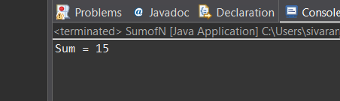
Program 10: Multiplication Table of a Number
class Multiply{
public static void main(String[] args) {
int n = 14;
for (int i = 1; i <= 10; i++) {
System.out.println(n + " x " + i + " = " + (n * i));
}
}
}
Output
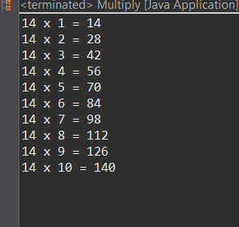

POST LAB EXERCISE
- What is the use of if statement?
- The if statement is used for decision making in a program.
It allows a program to execute a block of code only when a condition is true.
- Difference between if-else and else-if ladder.
Feature | if-else | else-if ladder
Purpose | Handles two conditions | Handles multiple conditions
Flow | Either if block or else block executes | Checks many conditions one by one
Use Case | True/False decisions | Choose among many options
Example | Pass or Fail | Grade A, B, C, D

- Why is switch statement used?
A switch statement is used when you need to choose one block of code from many possible options, based on a value.
Use:
Cleaner and easier than many else-if statements
Used for menu choices, days, grades, characters, etc.
Works with:
int
char
String

- Difference between for, while, and do-while loops.
Loop | Condition Check | Entry/Exit | When to Use
for loop | Before loop starts | Entry-controlled | When number of iterations is known
while loop | Before each iteration | Entry-controlled | When number of iterations is unknown
do-while loop | After executing once | Exit-controlled | When you want the loop to run at least once

- Which loop executes at least once?

do-while loop
Because the condition is checked after the first execution, so the loop body runs at least once, even if the condition is false.

Result:

Thus the different control statements were executed successfully with expected output.

ASSESSMENT

Description | Max Marks | Marks Awarded
Pre Lab Exercise | 5
In Lab Exercise | 10
Post Lab Exercise | 5
Viva | 10
Total | 30
Faculty Signature

